**Comp 9331 Ass Report**

**StudentID: z5184142 StudentName:JiachenLi Language use:Python3.7**

**1. A brief discussion of how you have implemented the STP protocol. Provide a list of features that you have successfully implemented. In case you have not been able to get certain features of STP working, you should also mention that in your report.**

To the STP protocol, I have constructed a class, which is called STP. This class contains eight elements and it is shown in the table below.

|  |  |
| --- | --- |
| Syn_bit | Synchronous Sequence Number |
| Ack_bit | Reply for Syn/Fin Number |
| Fin_bit | Fin Number |
| Seq_number | Packet Sequence Number |
| Ack_number | Packet Ack Number |
| payload | For Carrying Data |
| lengthofdata | Length of Carrying Data |
| checksum | Md5 for checksum |

The function of the program is shown in the table below.

|  |  |
| --- | --- |
| ThreeHandShakeFunction | Contains |
| CloseConnectionFunction | Contains |
| SendFile | Contains |
| ReceiveFile | Contains |
| PLDFunction | Contains (but the delay function has some bugs, when it goes to delay, all threads will stop until it sends the packet, so the timer will not retransmit if delay time is longer than TimeoutInterval.) |
| Timeoutdetect | Contains |
| FastRetransmit | Contains |

**2. A detailed diagram of your STP header and a quick explanation of all fields (similar to the diagrams that we have used in the lectures to understand TCP/UDP headers).**

STP header:

|  |  |
| --- | --- |
| Syn_bit | Synchronous Number |
| Ack_bit | Reply for Syn/Fin Number |
| Fin_bit | Fin Number |
| Seq_number | Packet Sequence Number |
| Ack_number | Packet Ack Number |
| payload | For Carrying Data |
| lengthofdata | Length of Carrying Data |
| checksum | Md5 for checksum |

**3. Discuss any design trade-offs considered and made. Describe possible improvements and extensions**

The timer is not designed well, especially when the packet is going to be delay transmitted. The timer will stop instead of continue calculating the Timeout Interval. Also, the timer may clash if the receiver is dealing with the self.timer_list, which makes me to make the sleep time of timer becomes longer. The corrupted packet that I modified, is just replace the payload with b’#’, which may not satisfy the requirements.

**4. Indicate any segments of code that you have borrowed from the Web or other books.**

[**https://github.com/jin-zhe/reliable-UDP/blob/master/Sender.java**](https://github.com/jin-zhe/reliable-UDP/blob/master/Sender.java)

**5.**

**(a)**

**Test Case:** **pDrop = 0.1, MWS = 500 bytes, MSS = 100 bytes, seed = 100, gamma = 4**

**Sender: Receiver:**



**Test Case: pDrop = 0.3, MWS = 500 bytes, MSS = 100 bytes, seed = 100, gamma = 4**

Discuss: With the drop percentage becomes a litter bit larger, from 0.1 to 0.3. It can be found the Timeout Interval is becoming longer with the packet drop.

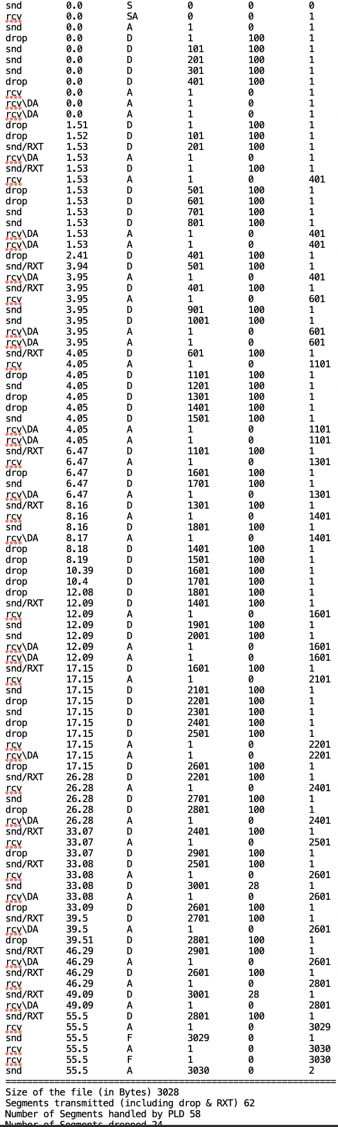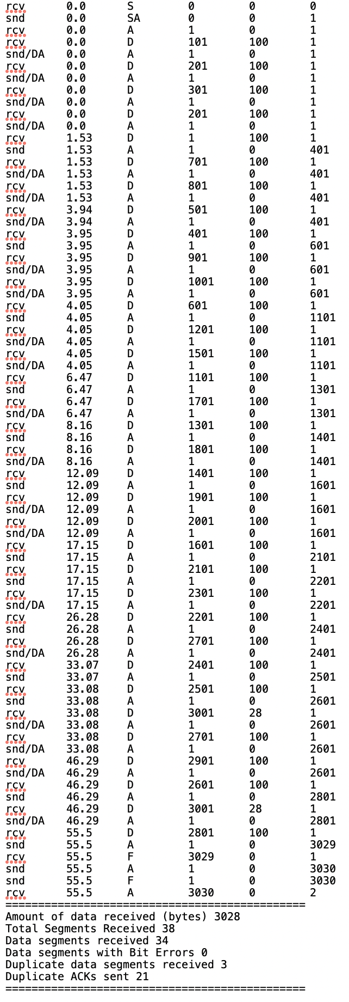**Sender: Receiver:**

**(b): not test yet. Because there are some problems in delay, which will cause extremely long time to wait.**

**(c):** **MWS=500bytes MSS=50 gamma=4 pDrop=0.1 pDuplicate=0.1 pCorrupt=0.1**

**pOrder=0.1 maxOrder=4 pDelay=0 maxDelay=0 seed=300**

The file is successful transmitted, it took almost two and half minute to transfer. The pDrop is the most critical contributing in the overall transfer time. Because the pDrop will make the Timeout Interval becomes longer.

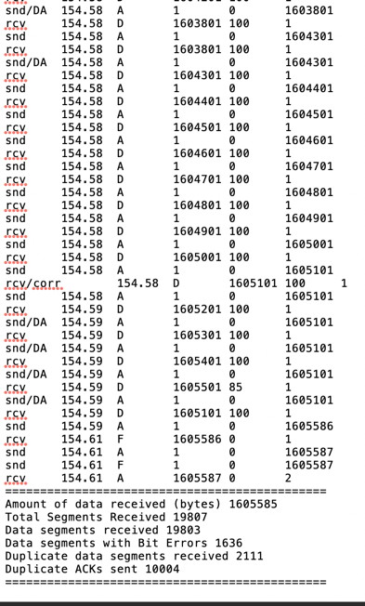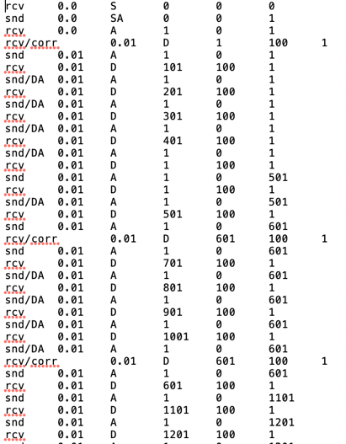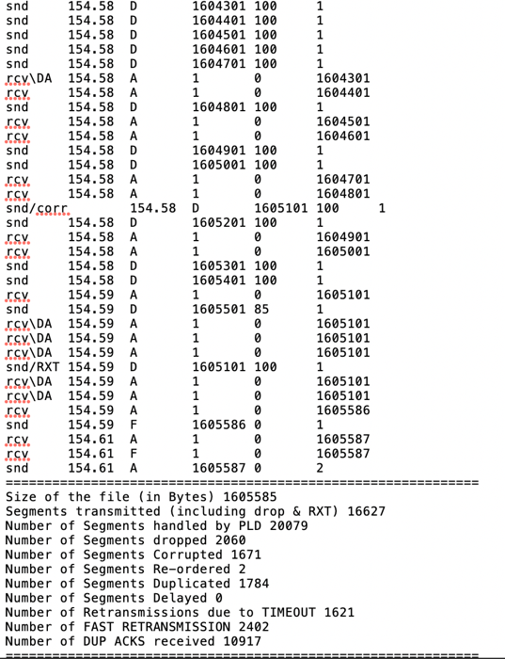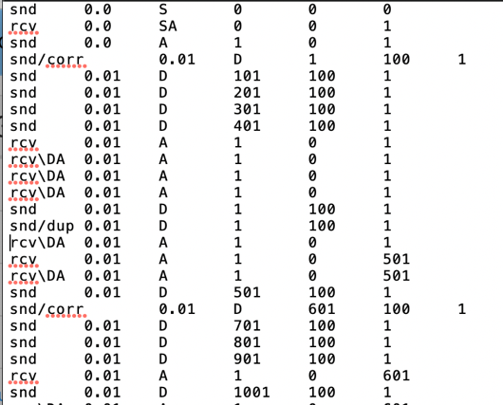**Sender: Receiver:**